1 September 2026
Today’s Topics
- Field-Level Security
- Record-Level Security (OWD)
- VS Code + Salesforce CLI
- Naming Conventions
- Apex Class / Developer Console

Field-Level Security (FLS)
Field-Level Security controls which fields a user can see or edit.
FLS can be configured through:
- Profile
- Permission Set
Profile vs Permission Set
Profile:
If you give field access through a Profile, the access applies to all users having that Profile.
Permission Set:
Permission Sets can give additional field access to selected users.

Field-Level Security by Profile
Object: Opportunity
Suppose Opportunity has two fields:
- Tracking Number
- Order Number
User Story
User | Profile | Order Number | Tracking Number
Bunty | Sales Agent | Visible | Not Visible
Babli | Sales Agent | Visible | Not Visible
Kapala | Sales Manager | Not Visible | Visible
Why?
Bunty and Babli both have the Sales Agent profile, so the same field-level access applies to both.
Kapala has the Sales Manager profile, so he gets different field-level access.

Steps — Sales Agent Profile
- Open Sales Agent Profile.
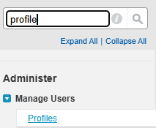
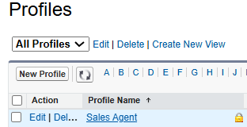
- Go to the Opportunity object.
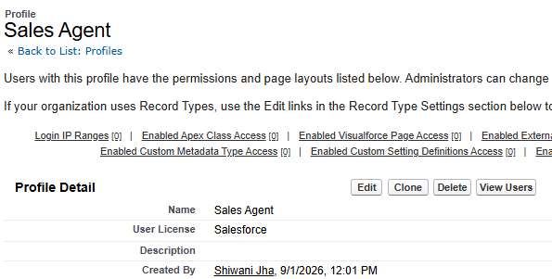
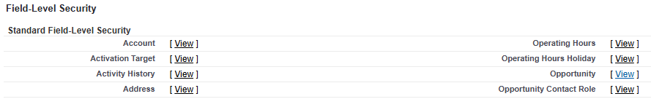
- Open the field-level settings.
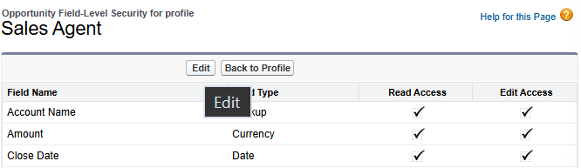

- For Order Number → make it Visible.
- For Tracking Number → make it Not Visible.
- opening Sales Agent → scrolling down → Opportunity → Edit/view field access.
Verify with Babli
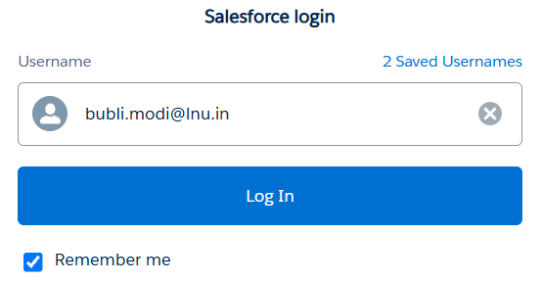
Login with Babli's Sales Agent account.
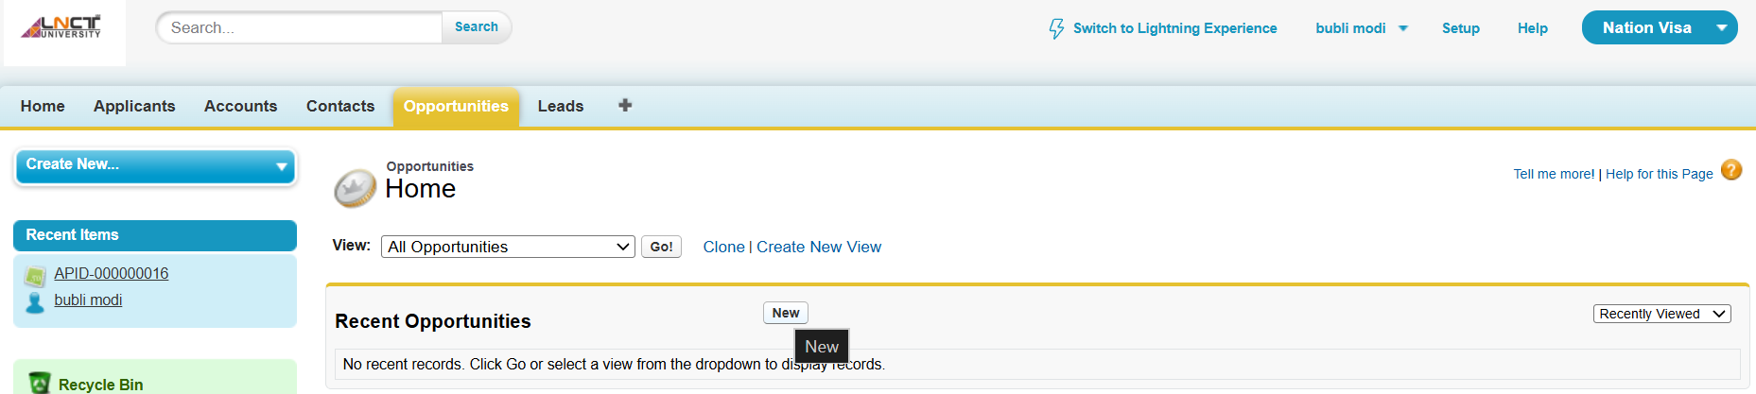
Open an Opportunity record.
Expected:
- Order Number → Visible
- Tracking Number → Not Visible
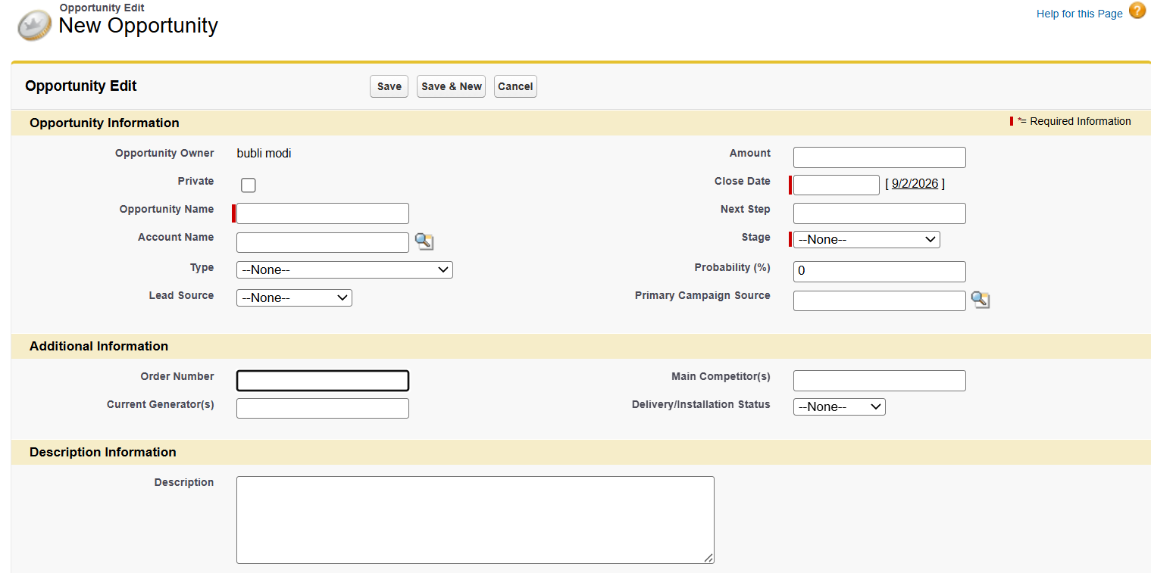
Steps — Sales Manager Profile
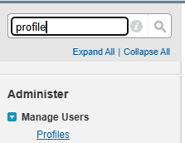
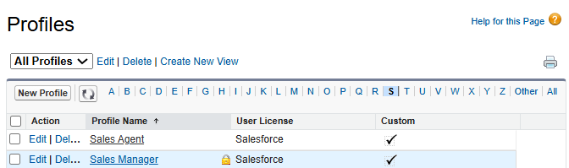
Open Sales Manager → Opportunity → field visibility.
Set:
- Tracking Number → Visible
- Order Number → Not Visible
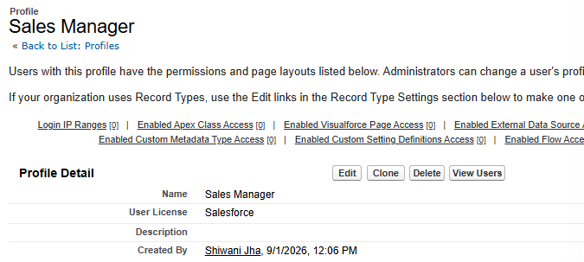
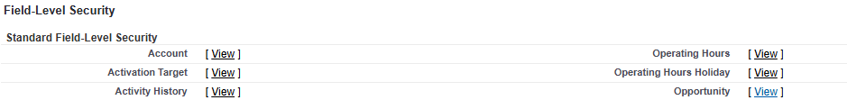
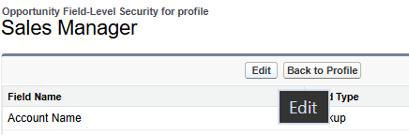
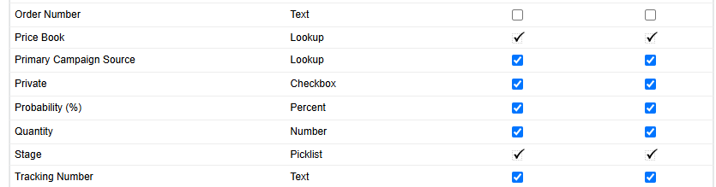
Verify with Kapala
Login with Kapala's Sales Manager account.
Open an Opportunity record.
Expected:
- Tracking Number → Visible
- Order Number → Not Visible
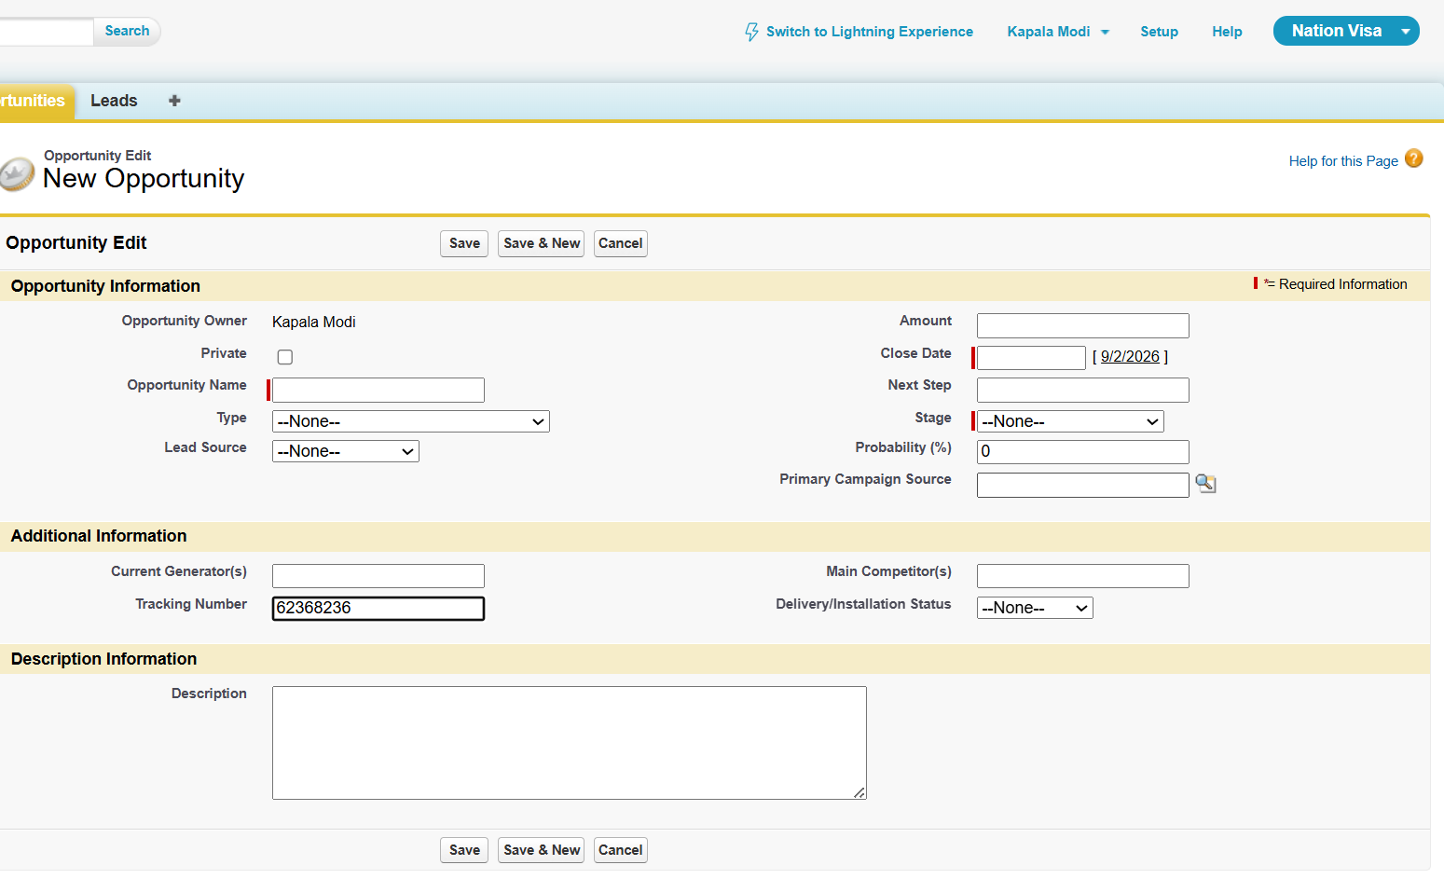
Important Point
Field visibility does not automatically mean record/data access.
For example, a field can be visible on the page, but the user still needs the appropriate object/record permissions to actually access the record/data.
So remember: Field visibility ≠ complete record access

Field-Level Security by Permission Set
Object: Applicant
Field: Mobile Number
User Story
User | Profile | Mobile Number
Bunty | Sales Agent | Read
Babli | Sales Agent | Read + Edit
Kapala | Sales Manager | Read
The class example demonstrates giving extra access through a Permission Set.

Step 1 — Create Mobile Number Field
Go to: Applicant → Custom Fields → New
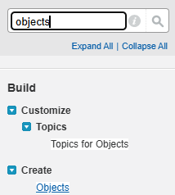
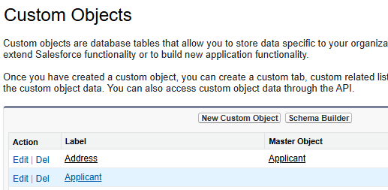
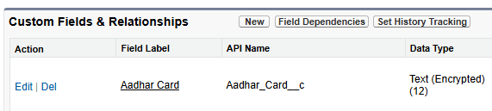
Select: Phone
Field Label: Mobile Number
Then: Next → Next → Save
Give Read Access through Profile
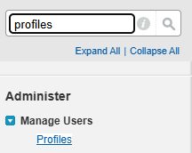
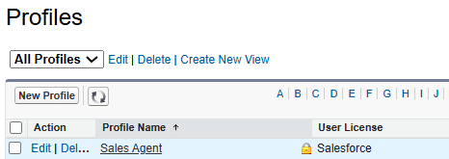
Open: Sales Agent → Applicant → Field Permissions
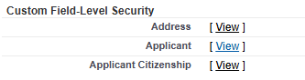
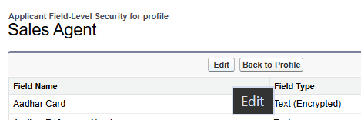
Give Read access to the Mobile Number field.
Now Bunty, who has the Sales Agent profile, can read the field.
Verify: Login as Bunty.
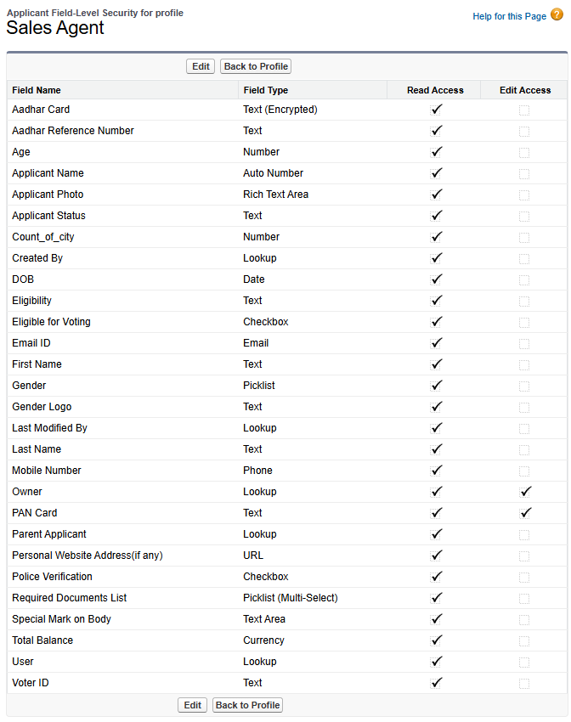
It can only see, can’t change. So only pan card has edit option.
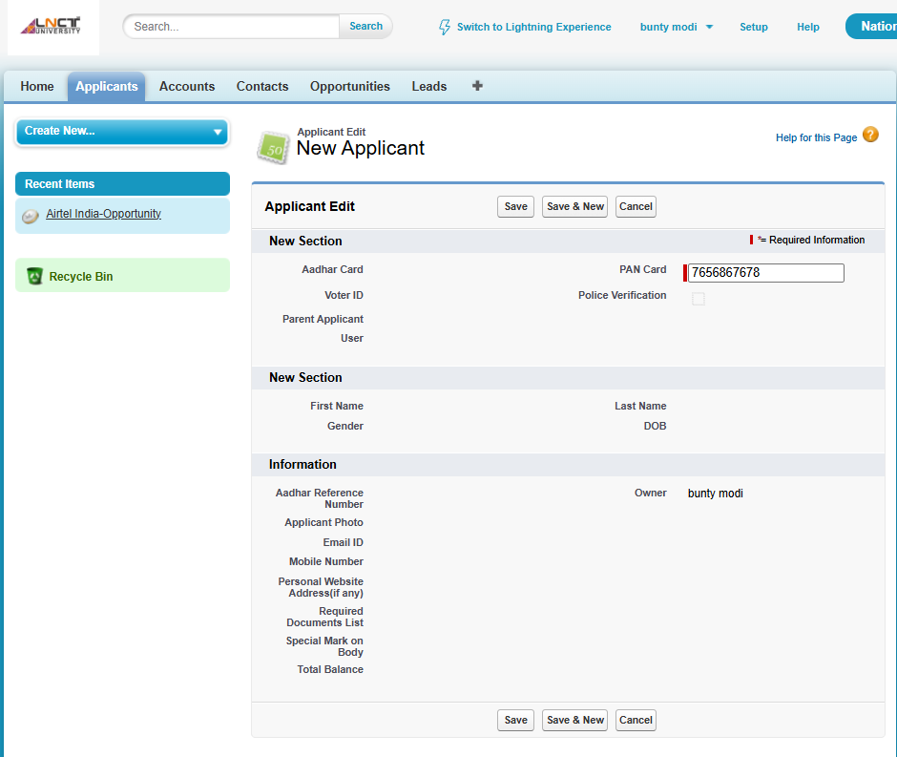
Check Applicant.
Expected:
- Mobile Number → Can Read
- Mobile Number → Cannot Edit

Give Extra Edit Access through Permission Set
Suppose Bunty now needs to edit the Mobile Number.
Instead of changing the Sales Agent Profile—which would affect all Sales Agents—we use a Permission Set.
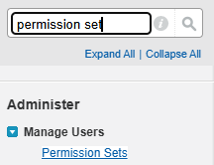
Create Permission Set Go to: Setup → Permission Sets → New
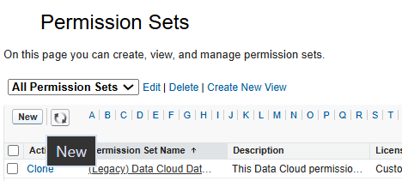
Example Label: Mobile Number Edit and Create License: Salesforce Click Save.
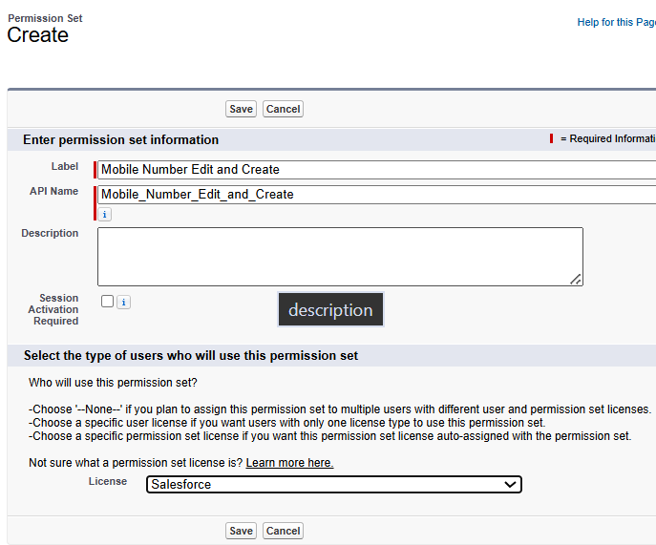
Configure Permission Set
Go to: Permission Set → Object Settings → Applicant → Field Permissions
Step 1
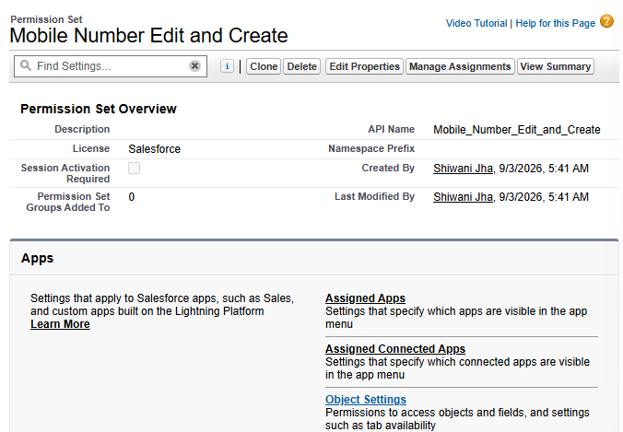
Step 2
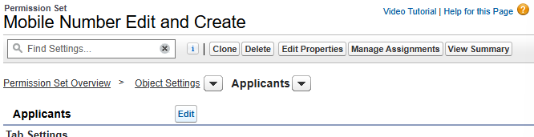
Step 3
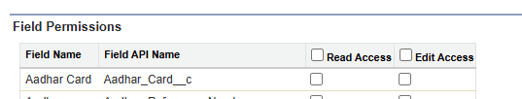
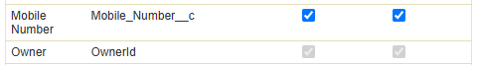
Find: Mobile Number
Give the required permission: read and edit.

Assign Permission Set
Go to: Manage Assignments → Add Assignment
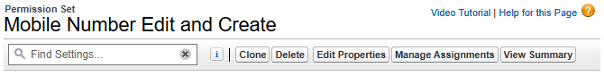
Select: Bunty Then: Assign / Done
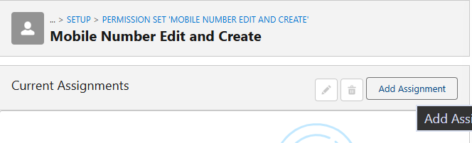
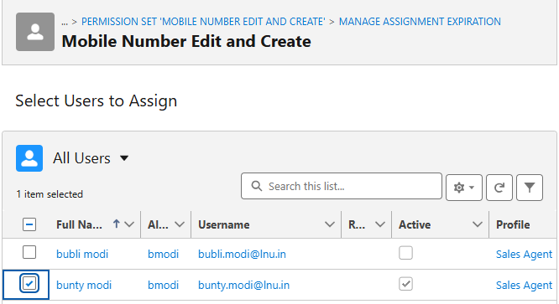
Verify Login as Bunty again.
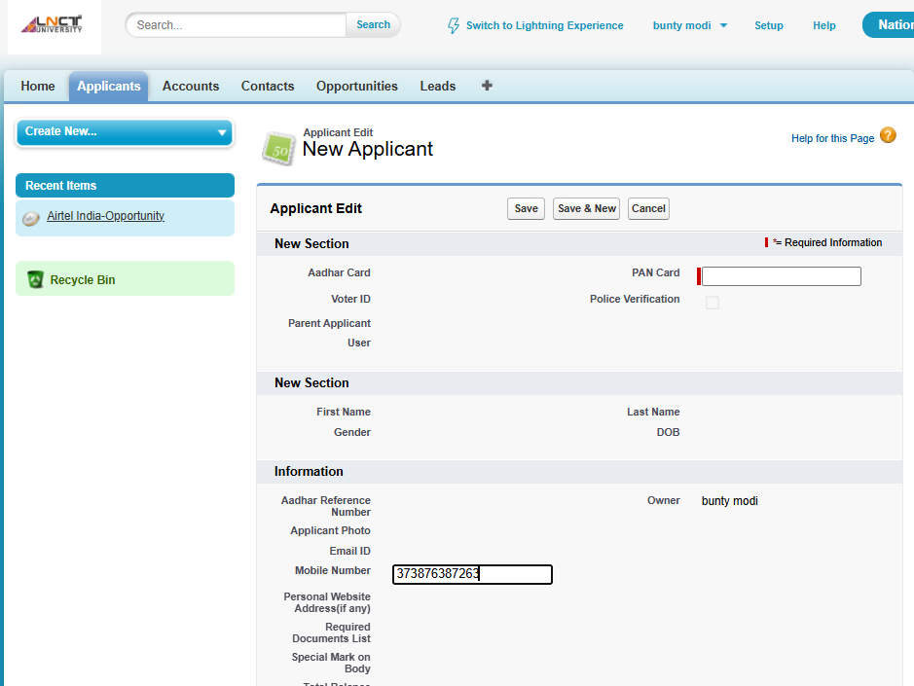

Now: Mobile Number → Read + Edit
So Bunty's final access comes from:
Sales Agent Profile + Permission Set

Question: Field Hide Karne Ke Kitne Tarike Hain?
There are 2 methods mentioned in your class:
1. Field-Level Security
Control field visibility using:
Profile / Permission Set
2. Page Layout
Control whether the field appears on the page/layout.
These are two different mechanisms. Field-Level Security is security-level control; Page Layout controls the field's presentation on the page.

Record-Level Security — OWD
private | Only owner can read/ write the record
Public read only | Only owner can edit the record, other users can read only
Public read & write | Everyone can access the record (READ/WRITE)

OWD = Organization-Wide Default
OWD controls the baseline record-level access for users in the organization.
Go to: Setup → Sharing Settings → Object → Applicant
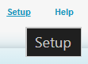
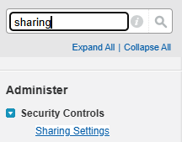
Then configure the OWD.
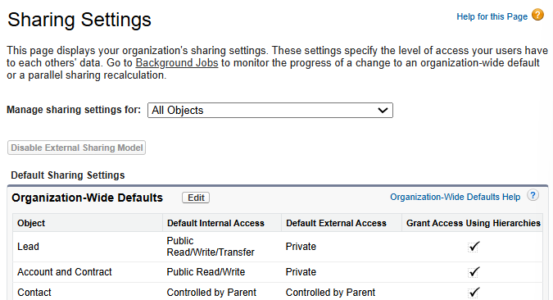
Your class example: Applicant = Private

OWD Options
1. Private
Only the record owner and users who receive additional access through appropriate mechanisms can access the record.
Basic idea:
Owner → access
Other users → restricted by default
2. Public Read Only
Users can generally read records, but editing is restricted.
Read → allowed
Edit → restricted
3. Public Read/Write
Users can generally:
Read + Write
the records.
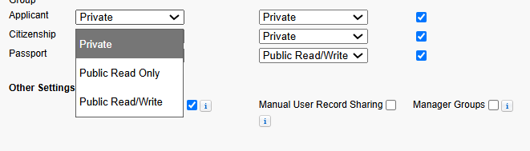

OWD Quick Table
OWD | Basic Access
Private | Restricted; owner gets access by default
Public Read Only | Users can read, but not generally edit
Public Read/Write | Users can read and edit
Important
Your notes say: Object level superior → Field level → Record level / OWD weak
A safer way to understand this is:
- Object permissions decide whether the user can access the object at all.
- Field permissions decide which fields the user can see/edit.
- OWD establishes the baseline sharing/access to records.
So OWD being Private does not override object-level permissions; all these layers work together.
Field Level Security 2 ways: Profile & Permission Set
Field Hide: 1. Field-Level Security 2. Page Layout
Record Level Security
OWD- Private, Public Read Only, Public Read/Write
Profiles: 1 user → 1 Profile
Permission Sets: 1 user → multiple Permission Sets
Profile = baseline access
Permission Set = extra/additional access
FLS = field access
OWD = record-level baseline sharing

VS Code + Salesforce CLI
Vs code Extension-
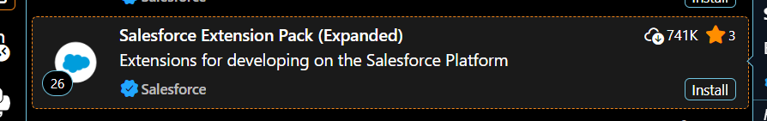
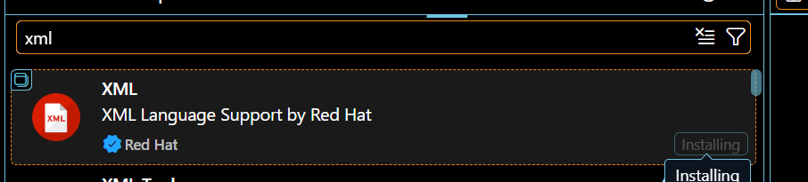
Salesforce cli
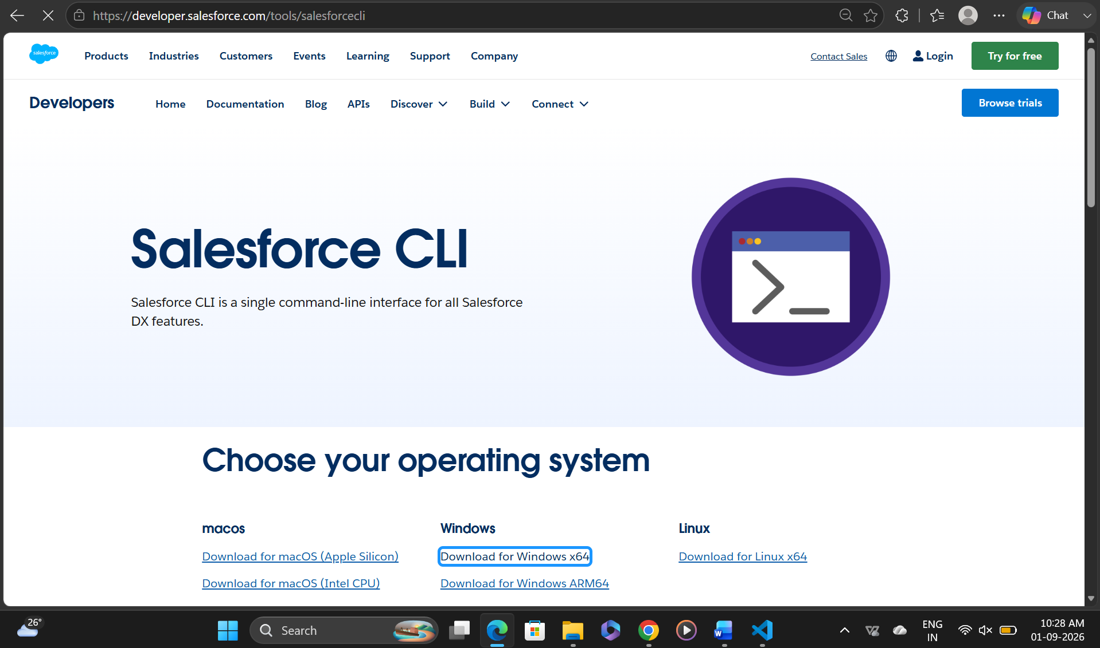
Salesforce CLI
In the VS Code terminal: sf update
This updates Salesforce CLI.

Create Salesforce Project in VS Code
Press: Ctrl + Shift + P
Search: SFDX: Create Project with Manifest
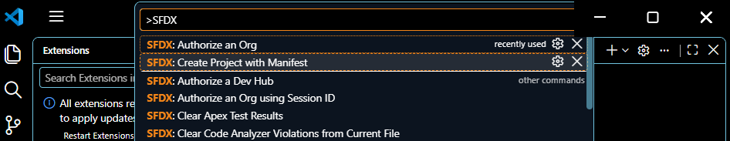
Select: Standard
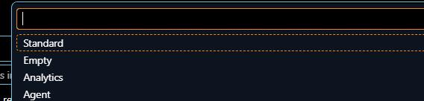
Project Name: LNCTU
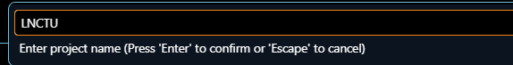
The project will be created with the Salesforce project structure.

Authorize Salesforce Org
Press: Ctrl + Shift + P
Search: SFDX: Authorize an Org
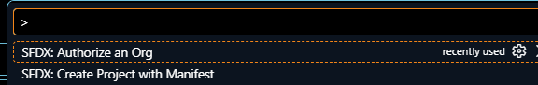
Select: Production

Enter the project/alias name: LNCTU
Salesforce login page will open.
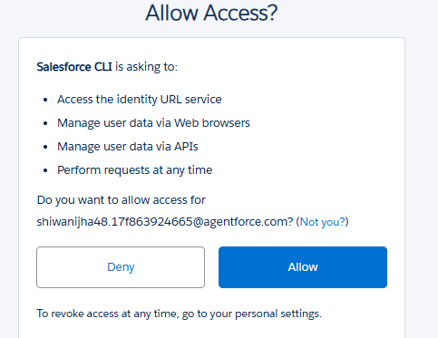
Enter your Salesforce credentials and login.
After successful login: Authentication successful
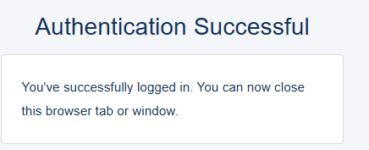

File Structure
The project contains: Manifest
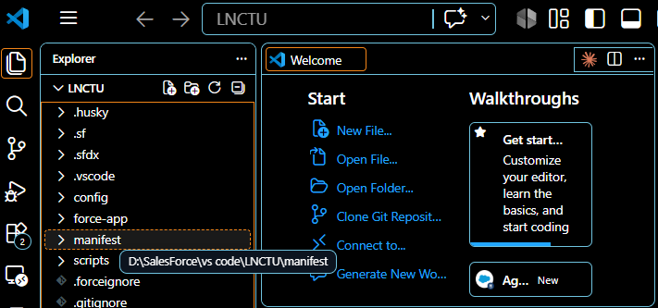
Inside the Manifest folder: .xml file
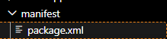
The XML manifest is used to specify Salesforce metadata/components to retrieve or work with.

Naming Conventions
These are the naming conventions written in your notes:
Case | Example | Common Use
snake_case | student_name | Variables/data naming in some languages
camelCase | studentName | Variables, methods
PascalCase | StudentName | Classes
kebab-case | student-name | Some naming contexts
Salesforce/Apex notes from your class
- Apex Class Name → PascalCase
- Class Name → PascalCase
- Variable Name → camelCase
- Method Name → camelCase
- Object Name → API Name
- Relationship Name → kebab-case
Example
Class: Applicant2sept
Variable: applicantName
Method: getApplicant()
Apex Class
Apex Class Name: Applicant2sept
And the next topic is: Developer Console
This is where you can write and execute/test Salesforce Apex code.
Apex class name= Applicant2sept
CODE –
Developer Console-
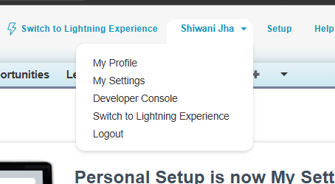
DEVELOPER CONSOLE
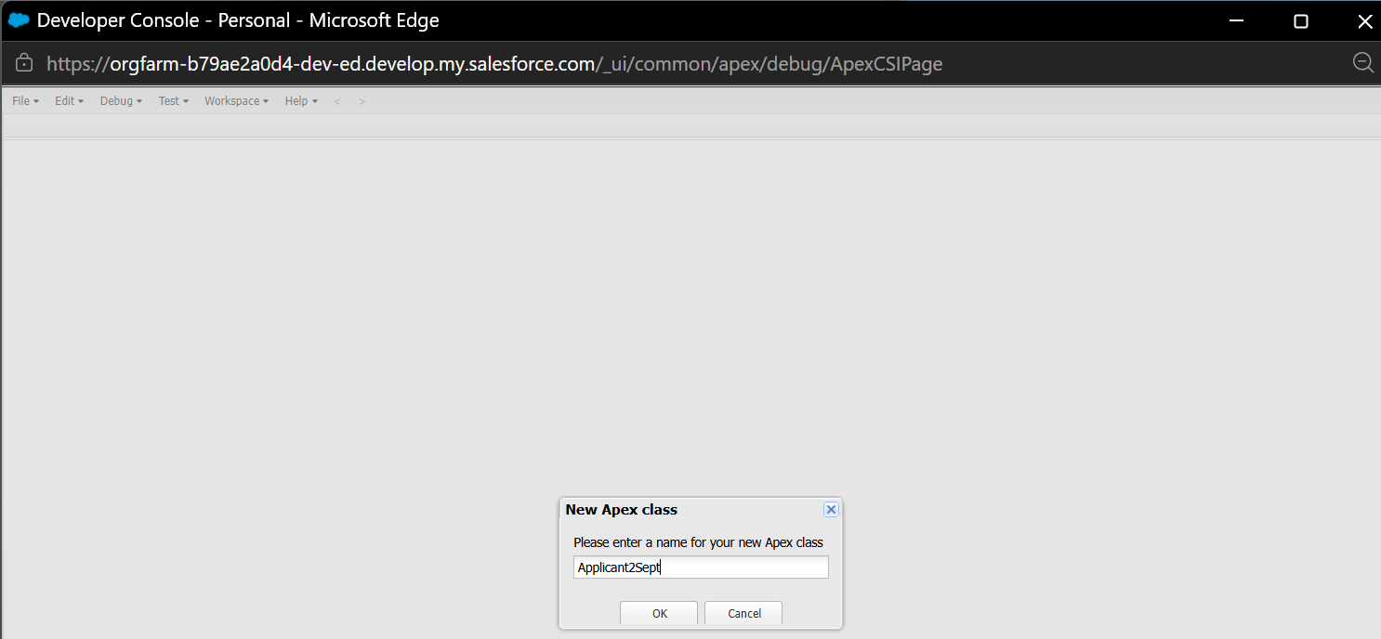
Code-
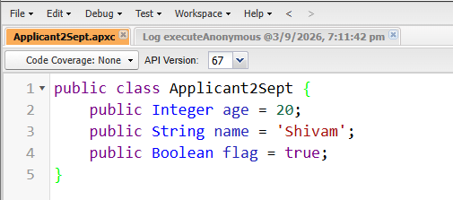
Save it
Click on debug open execute anonymous window or ctrl + E
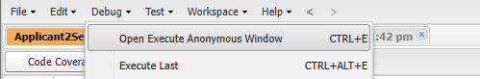
Then write this-
Applicant2Sept objApplicant2Sept = new Applicant2Sept();
System.debug(objApplicant2Sept.age);
System.debug(objApplicant2Sept.name);
System.debug(objApplicant2Sept.flag);
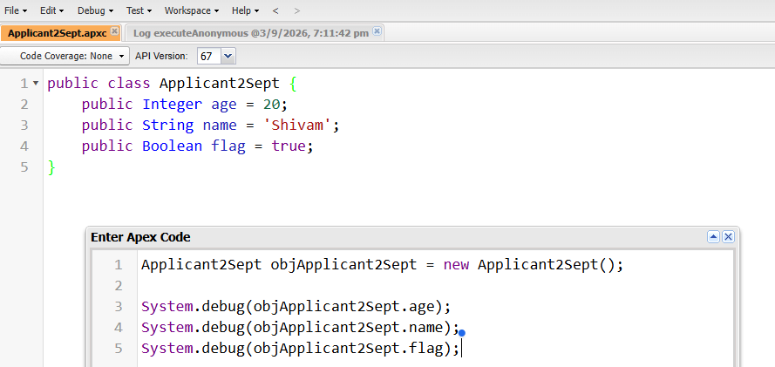
Click on Execute-
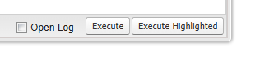
To see result/ output-
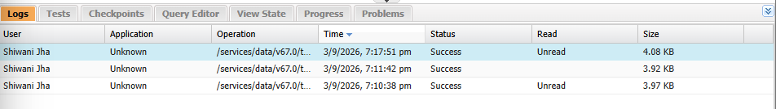
Click on the “success” double click
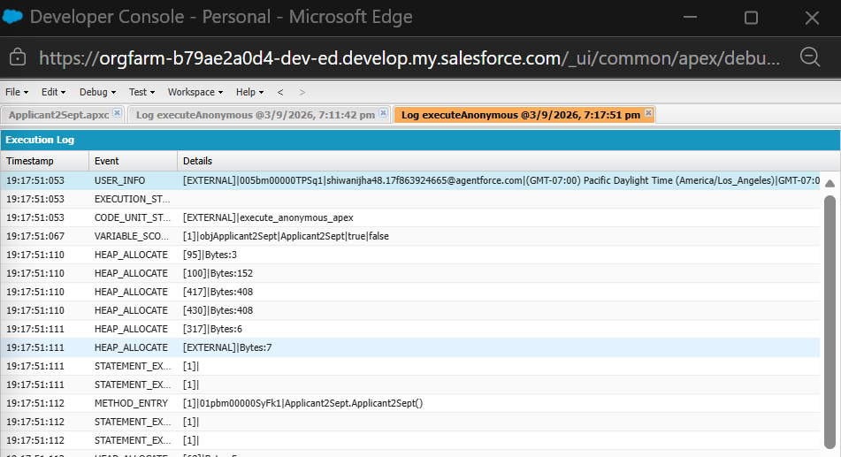

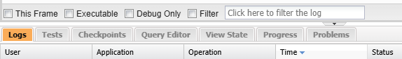
Now tick on “debug only”
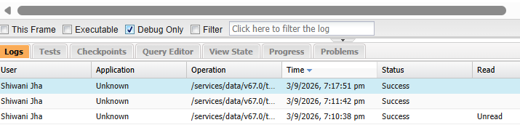
Now see the output
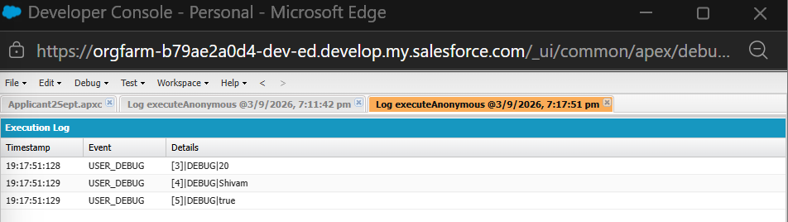

Authorise time some error-
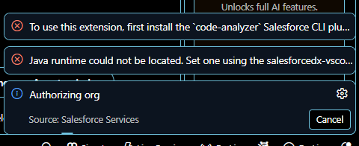
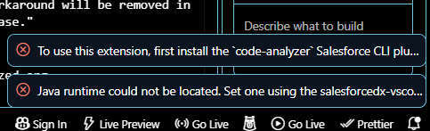

There are two different ways you'll usually run Apex:
- Anonymous Apex → output goes to Logs
CODE –
public class Applicant2Sept {
public Integer age = 20;
public String name = 'Shivam';
public Boolean flag = true;
}
When you write:
Applicant2Sept obj = new Applicant2Sept();
System.debug(obj.age);
System.debug(obj.name);
System.debug(obj.flag);
You click Execute; Salesforce runs it and creates a Log.
Then:
Logs → double-click log → Debug Only → see output
So yes, for System.debug(), this is the normal Developer Console workflow.
2. But later, you'll mostly use SOQL / actual Salesforce data
For example:
SELECT Id, Name FROM Account
You can use the Query Editor, execute it, and Salesforce shows the records directly in a table.

